Sign up for universal free school meals now!

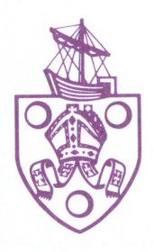

**Dear parent/carer**

I am writing to you as you have a child who will be starting in Reception with us in September 2024. All our infant children are currently eligible to receive a school meal at no cost to the parent/carer* through the Governments’ Universal Free School Meal scheme. School meals at St Nicolas are healthy, tasty, social and fun and choosing a school lunch for your child/children will help save you up to £480.70 per year.

Quality food, every day…

We have meals freshly prepared every day, by our school meal service provider is Oxfordshire County Council using high quality ingredients from local suppliers which provide the right amount of energy to ensure that children can work better in the afternoons.

• All meat used is British and meets the red tractor standard

• All eggs used are free range and sourced locally

• 75% of our dishes are cooked from scratch

• All fish served is Marine Stewardship Council (MSC- certified sustainable seafood)

• Fresh fruit or a yogurt is available as an alternative to the dessert every day

Meat and vegetarian options are available every day, and we can cater for children who have other dietary requirements. This can include religious, cultural or allergy and/or intolerance diets. You can see the current school menu on the school website [www.stnicolasprimary.co.uk](http://www.stnicolasprimary.co.uk) – Parents– school meals.

As well as a hot meal we also offer a daily brunch option which typically includes a sandwich with a variety of fillings, drink, piece of fruit and yogurt or cake/biscuit. Both, the hot meal and the brunch options meet the children’s Food Trust nutritional guidelines.

To help us plan for your child for September, please complete the attached form. This will ensure that we are able to claim the correct level of funding and help us plan for your child having a school lunch from September 2023.

Yours sincerely,

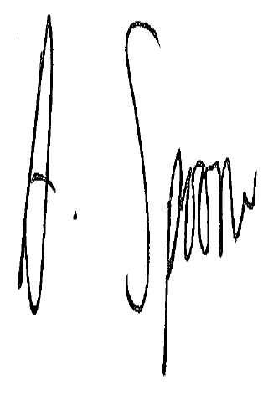

Mr Andy Spooner

Headteacher

*NB: A cash alternative is not available for those pupils not taking a school lunch.*

**All our infant children are offered a daily free healthy school lunch. To assist us in the process and planning we require the following information from you. All data held for your child is bound by the General Data Protection Regulations.**

Yes No

Will your child require a menu to meet special dietary needs?

If yes, please provide a brief description e.g. gluten free, vegetarian etc. This information will be shared with our school catering contractor.

|  |
| --- |
|  |

**Information about you and your child – please complete.**

This information will be used by the school to check for eligibility to claim additional grant money (‘pupil premium’) and shared with central government. It will not be used for any other purposes and will remain confidential to school. **There are additional benefits that we offer to children that qualify i.e. school uniform voucher, assistance with residential trips and access to the school’s breakfast club.**

Do you currently receive free school meals for any other children? Yes No

**Parent/Carer details**

|  |  |  |  |  |  |  |  |  |  |  |  |  |  |
| --- | --- | --- | --- | --- | --- | --- | --- | --- | --- | --- | --- | --- | --- |
|  | **Parent/Carer**  **Surname** | **Parent/Carer Forename** | **Parent/Carer**  **Date of birth**  **DD/MM/YY** | **National Insurance Number** | | | | | | | | | |
| **1** |  |  |  |  |  |  |  |  |  |  |  |  |
| **2** |  |  |  |  |  |  |  |  |  |  |  |  |

**Child details**

|  |  |  |  |  |  |  |
| --- | --- | --- | --- | --- | --- | --- |
| **Child’s name** | **Child’s Forename** | **Child’s Date of Birth DD/MM/YY** | | | **School** | **Year Group (from Sept 16)** |
|  |  |  |  |  |  |  |

**Current Address**

|  |
| --- |
| **Postcode:** |

**Daytime telephone number**

|  |
| --- |
| **Mobile: Home** |

Thank you for completing this form – please return it as soon as possible. If you should have any questions, call the school office 01235 520456.